Title: Recalibrating the power of guns
Everyone is talking about guns.
In the USA, people are talking about banning guns in the aftermath of the 2nd deadliest school shooting in American history. In Canada, we’re talking about the Battleford Saskatchewan farmer whose semi-automatic pistol killed a 22-year old indigenous man, Colten Boushie, trespassing on his property.
Every day, there are protests.
American teens are walking out of school, nation-wide, reminiscent of 1960’s anti-Vietnam protests. (Except, now, American youth are dying on American soil, killed by weapons wielded by their own.) In Canada, First Nations and politicians are questioning the all-white jury’s conclusion. The jury that unanimously found Gerald Stanley ‘not guilty’ of second degree murder or manslaughter.
Everywhere, opposing sides are forming up to seriously recalibrate the power of guns.
The anti-gun side says ban all guns. Hand guns, semi-automatic rifles, BB guns. The works. Do it now or we’ll have more massacres. We will be at risk.
The pro-gun side says don’t compromise the right to bear arms, the right to protect yourself. Kids can’t bear arms so, heck, let’s arm their teachers. If we capitulate, we’ll have lawlessness. We will be at risk.
Maybe you have already picked a side? If not, keep reading.
Personally, I’m skittish around guns. But I’m not afraid of wading into this increasingly polarized debate. Arguably, there are times ‘no guns’ can work. And there are times you may need a gun to protect yourself. Both scenarios are rare. Most of the time, we need choices that lie in the wide space between these two divergent strategies.
What are your choices? What can you do? Here are 5 things you can do.
- Notice the guns in your world.
Guns exist for the purpose of killing; that’s their only purpose. That’s why they work to deter.
I notice guns. If someone was carrying around poisonous gas or opioids, I’d notice that too.
One of your choices is to notice guns. To treat them as the exception, not the norm.
In Rome last September, soldiers with automatic weapons protecting the City, especially the Vatican, caused me to pause. The incongruity of it all. The Pope. And guns.
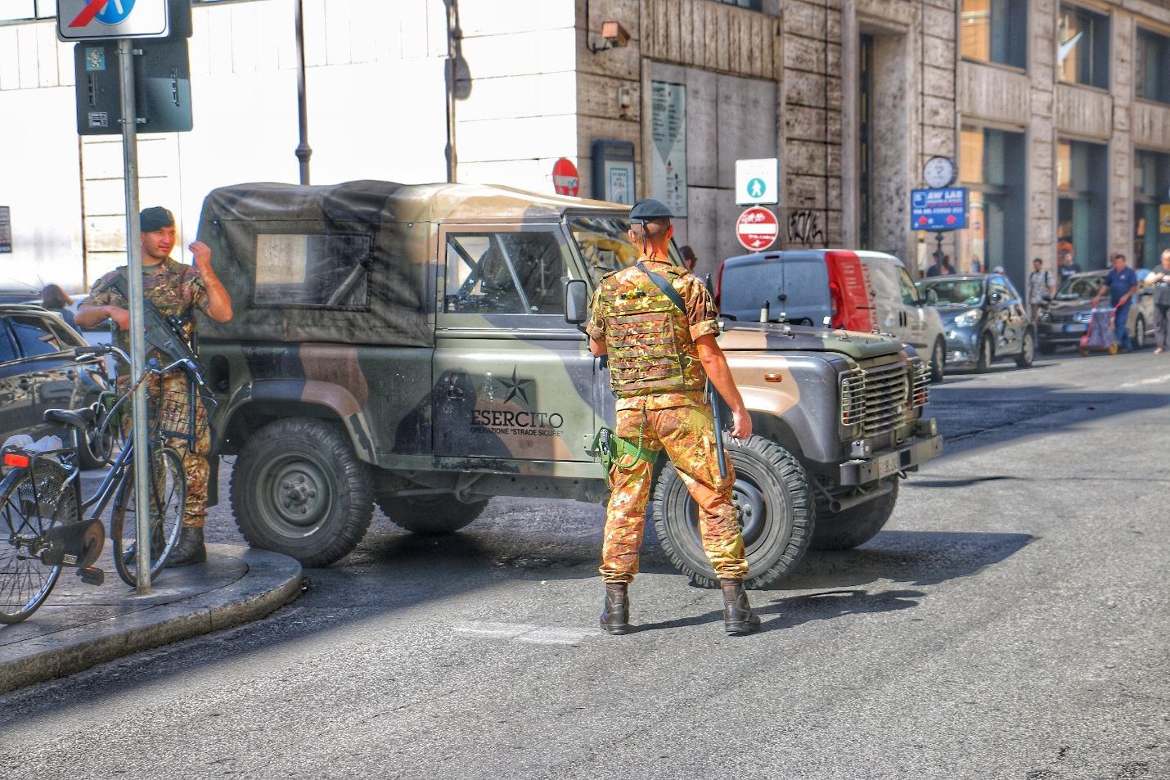
I handle guns rarely. And with trepidation. Sensing my discomfort, Yemenis were always asking me to pose with their semi-automatic weapons. They found my twitchiness bemusing.
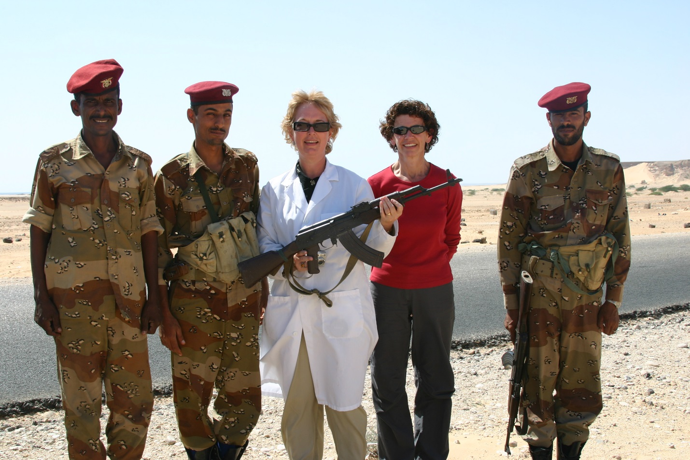
In places like Yemen, guns are ubiquitous. You can’t rent a piece of equipment or a car without a gun to offer up as security. People take guns to weddings, shooting rounds into the air to celebrate. It’s strange, but in a place where guns are ‘normal’, you get to the point where you stop noticing.
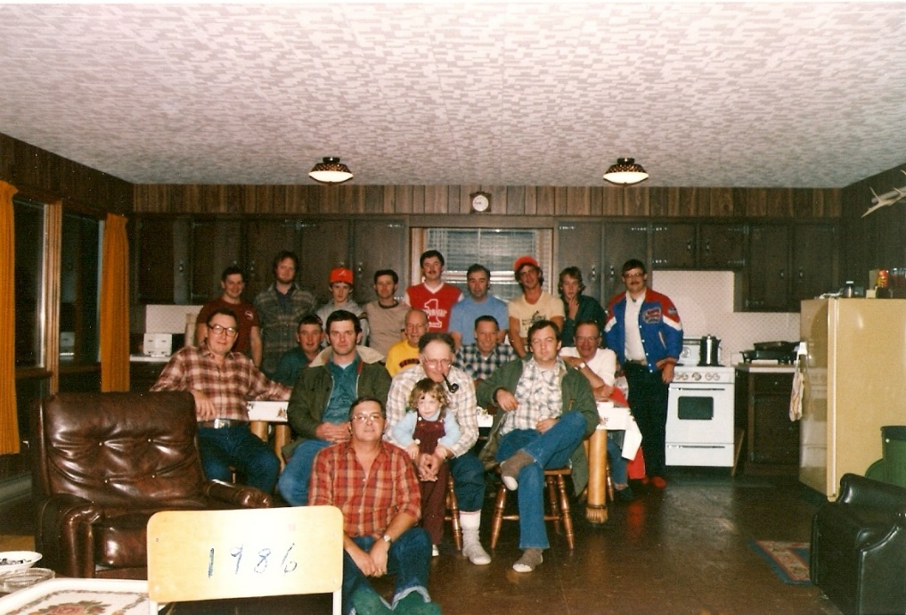
Dad’s deer hunting camp, Silverwater, Manitoulin Island
I grew up around guns. Not AK-47s like in Yemen, but hunting rifles. Even as a kid, I noticed them. Bullets removed and mounted in the pickup truck, or locked away in a cabinet. I also noticed how uber-alert my father became when he picked up a gun. You don’t point guns at people was a non-negotiable mantra we heard from the moment we could pick one up.
- Dare to ask gun-owners why they own guns.
You likely know people who have guns. Sometimes, their reasons are obvious. Hunters, security guards, police. But sometimes they aren’t.
Have you ever asked a gun-owner, “Why do you own a gun?” Given that guns exist to kill, it seems like a legitimate question.
I have friends in South Africa who started carrying concealed hand guns because of fear of rape. Gulp.
Some people hide guns under their beds to defend against trespassers. My Aunt Donna married a Virginian, a tobacco grower relocated to southern Ontario to transplant that crop in northern climes. Her father-in-law, Mr. Hamilton, kept loaded guns under his bed. It’s what he’d done in Virginia.
Other friends have guns they never use, inherited from fathers and grandfathers.
Fear. Security. Tradition. Sentimental reasons. Fair enough.
But what happens when a gun-owner acquires a gun as a way of responding to feelings of marginalization or shame? When the gun becomes the equalizer. Power borrowed by the powerless.
Who is asking isolated young men why they own semi-automatic weapons? Parents, teachers, friends, police, counsellors, neighbours? If I knew anyone with a semi-automatic weapon, I’d want to know why.
Not my business? Surely it is, now.
- Don’t ignore the connection between male shame and gun violence.
This isn’t politically correct to say. But the shooters in mass murders are male. Often, middle-class white males.
That fact smacks me between the eyes.
As a mother of three sons, I’ve always paid attention to their interest in guns. My husband and I didn’t ban toy guns. And we gave them dolls. But, I swear, our boys could make a chicken leg go Bam-Bam.
What’s the fascination? The masculine archetype is the protector, the aggressive competitor who saves the family from harm. But this is 2018!
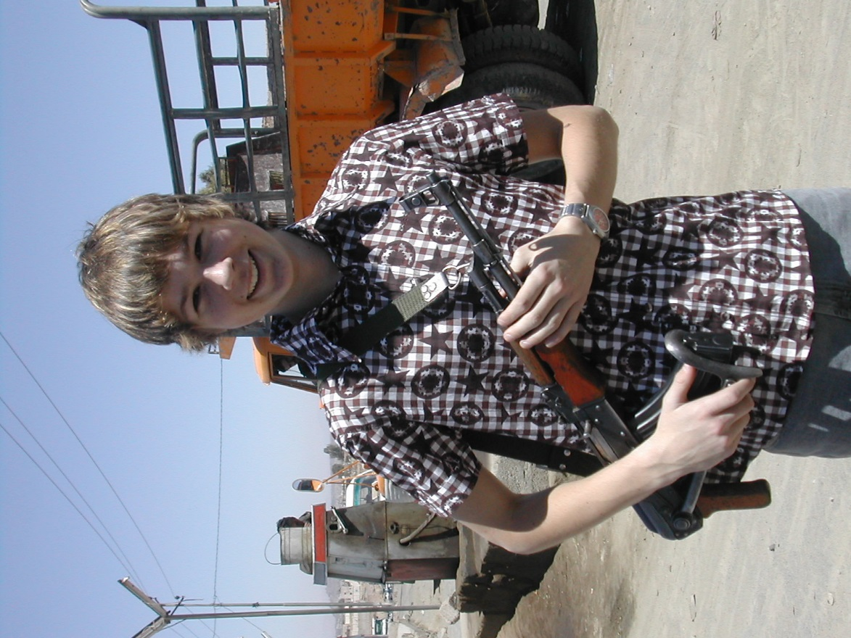
My son, Mitchell, in Yemen
Patriarchy is being seriously upended right now. #MeToo is a movement gaining momentum, not waning. Perhaps, entrenchment on gun rights is part of a reaction to a wider gender recalibration?
I’ve written before about angry white men, as the victims. About how some white males feel marginalized-- being passed over in favour of minorities and women and immigrants. They want to turn the clock back. #Badass and #Tough are still desirable hashtags, for some.
Michael Kimmel, a sociologist, and author of Angry White Men: American Masculinity at the End of an Era describes this as “aggrieved entitlement.” These men feel shame and humiliation. And, they respond with violence. Guns give them the power they crave.
What does this mean, for you? Paying attention to male shame and marginalization. Paying attention to isolated, angry men and their affinity for guns. This affects how institutions do security and mental health risking, of course. But it can also affect we reach out to males, ones we know and ones we don’t. To put a brake on shame.
In the Pyeongchang Winter Olympics, two South Korean speed skaters appeared to blame and marginalize a third team mate for the team’s failure the reach the semi-finals. People in South Korea are calling for these two skaters to be banned from the national team. Why? Because they publicly shamed a team mate. That’s what putting the brakes on shaming can look like.
- Recognize when your fear is being exploited.
In Canada, we have a culture of gun compliance.
If you own a gun, it has to be registered. It has to be stored safely. You need training to buy a gun. That old peace, order & good government vibe keeps strumming.
For the most part, Canadians aren’t afraid of being shot. Sure, we lock our front doors and our vehicles. And we care about security on airplanes and in stadiums. But most of us don’t feel our lives are being encroached upon by criminals, asylum-seekers, killers, hooligans or gypsies.
The shooting of Colten Boushie in Saskatchewan is being labeled by some as citizens’ rights to ‘stand their ground’, ‘protect their property’, and ‘defend our places.’ This all has a National Rifle Association ring to it.
Many of my family members live in rural places. They talk of neighbours who have had ATVs and trucks stolen. They talk of local teens getting high on drugs and vandalizing property.
But they don’t put loaded guns under their beds, and lay in wait.
I have American friends who say their gun culture is different. Regular folks seem more comfortable putting a handgun in their purse or glove compartment of their car. Parents are buying bullet-proof backpacks for their kids. And, of course, there is a big constitutional difference. Americans are very attached to their Second Amendment.
Friends of mine who are anti-gun activists claim the NRA isn’t really all that worried about protecting rights. The NRA isn’t really worried about shoring up bravado and self-reliance either. What they want is to make money selling more guns. To do that, they prey on citizens’ fears of getting shot.
If anyone is pushing your fear button, you need to understand why.
- Get creative with new ideas. Take action.

The “if you aren’t with us, you’re against us” people in the world want you to pick a side. Their side. Ban all guns vs. Arm everyone.
I’m suggesting something a little more creative.
Here are a few ideas that people I know are pursuing, to engage directly and authentically on this issue. You can too. And, please, share your ideas.
- A friend in Seattle posted this action on Facebook:

Well, I did it. Seventeen minutes of silence in front of the nearest school then chatting with passers by about why I was there. Haven't done this since the sixties. But now that I am officially a Pissed Off Old Lady and I'm not stopping until we see these kids succeed. Join me. #neveragain #marchforourlives #midtermsarecoming

- Lobby gun makers (and their funders) to take a leadership role in finding solutions. Like, following the pharmaceutics. They stopped selling opioids to pharmacies with suspicious ordering patterns. Like, embracing safety devices and smart-gun technology.
- #BoycottNRA is working. A call to boycott the NRA became the top trend on Twitter. Big-name companies are lining up to sever ties with the pro-gun advocacy group. Best Western, MetLife…

Bonus: And, just for fun.
This is heavy stuff. So, let me conclude on a lighter note.
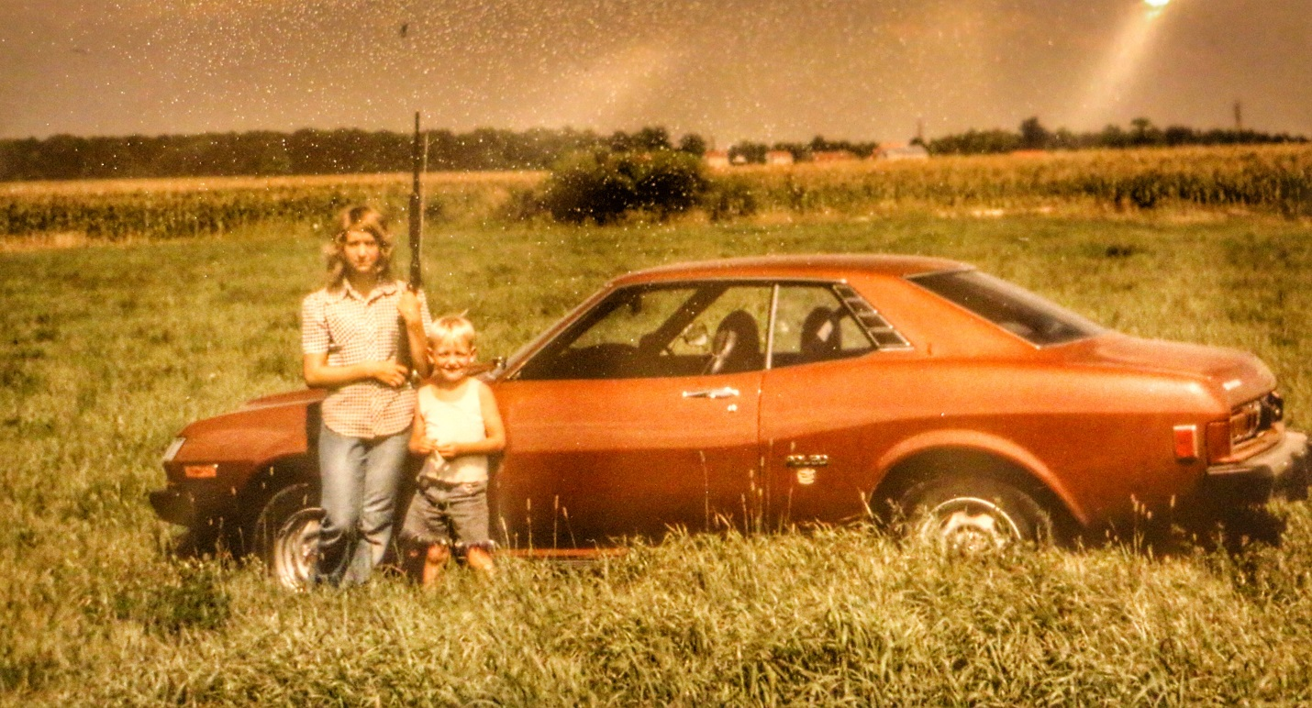
Decades ago, one of my city-slicker cousins from Detroit fond it amusing to stage “redneck” photos using my siblings and me—and guns—as props. Our mother was scandalized.

A shotgun wedding. This is my Great Uncle, Harry Almas, dressed as a ‘pregnant’ bride at my sister’s bridal shower. A shotgun was used to keep the reluctant groom at the altar.
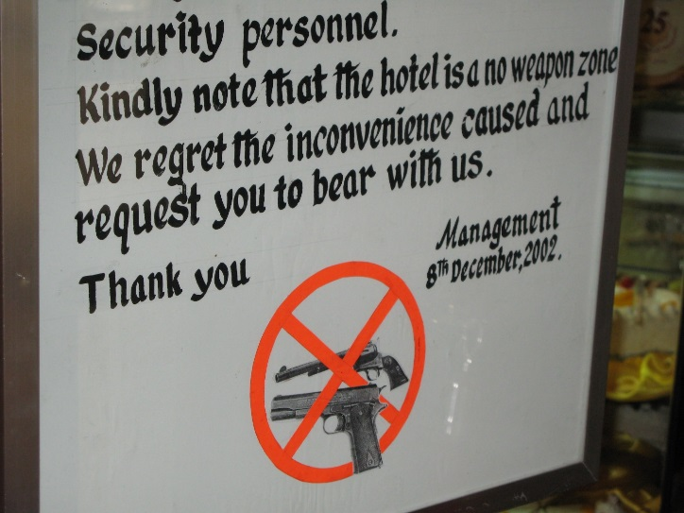
It’s all in the translation: Holiday Inn in Aden, Yemen

No matter where you stand on the subject of guns they have the meaning that we give them. The current uproar gives us the opportunity to examine those meanings for ourselves and become a little more conscious. Let’s give it a shot.

